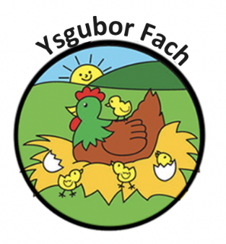

Staff recruitment and Employment Policy and procedure
Ysgubor Fach recognises the valuable contribution that well qualified and experienced staff makes to the experience in our care.
We do this by:
- Recruiting staff in an open and inclusive manner that in line with Carmarthenshire County Councils recruitment and selection policy
- Recruiting staff on the basis of qualifications, skills and experiences that best meets the needs of the children in our care.
- Meeting relevant legislative requirements (CIW, Health and Safety, Data Protection, Equality and Inclusion)
- Operating a clear and accountable induction period that includes health and safety and child protection policies
- Operating a clear and accountable staff discipline procedure
- Expecting staff to undertake continuous professional development and training
- Maintaining individual staff files
- Operating regular and recorded supervision and appraisal meetings between staff ana management
- Operating a staff code of conduct

Our Policies and Procedures are reviewed yearly.
Many Thanks,
Eleri Thomas

