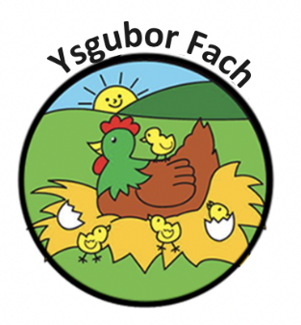

Selecting Toys and equipment policy
The toys and equipment at Ysgubor Fach provide opportunities for children to develop new skills and concepts in the course of their play exploration.

The equipment we provide;
- Is selected for the appropriate ages and stages of the children in our care
- Offers challenges to develop physical, social, personal and intellectual skills
- Features positive images of people both male and female, from a range of ethnic and cultural groups, with or without disabilities
- Include a wide range of raw materials which can be used in a variety of ways;
Encouraging an open-ended approach to creativity and problem solving
- Will enable children to develop individual potential and progress towards required learning outcomes.
- Confirms to all relevant safety regulations and is sound and well manufactured
- Is checked for breakages
- Is cleaned regularly

Our Policies and Procedures are reviewed yearly.
Many Thanks,
Eleri Thomas

