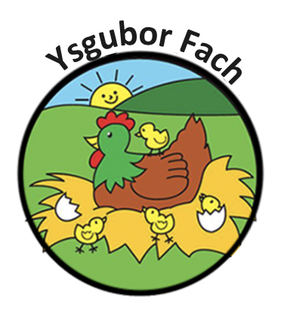

Our Equality Duties and Opportunities Policy
We aim to be a community where everyone is treated fairly and with respect. We want everyone to reach their potential, and recognise that for some children extra support is needed to help them to achieve and be successful. We take our legal duties on equality seriously.
We welcome our general duty under the Equality Act 2010 to eliminate discrimination, to advance equality of opportunity and to foster good relations.

Aims of our Equal Opportunities Policy
Equality of opportunity at Ysgubor Fach is about providing equality and excellence for all in order to promote the highest possible standards of care. Equality of opportunity applies to all members of the nursery community; children, staff, parents/carers and others in the wider nursery community.
We aim to ensure that the nursery meets the needs of all, taking account of ethnicity, culture, gender, sexual orientation, religion, language, age, ability, disability and social circumstances. It is important that in this nursery we meet the diverse needs of adults and children to ensure inclusion for all and that all children are prepared for full participation in a diverse, multi-ethnic and multi-lingual society.

Legislation and Requirement
The policy has been written with regard to the Code of Practice for Special Educational Needs; DFES/581/2014; The Equality Act 2010; The Statutory Framework for Early Years Foundation Stage (EYFS); Ysgubor Fach Special Educational Needs Policy; Behaviour Policy and Discipline Policy (2019) Equality and opportunity requires that everyone has an equal chance to develop themselves to their full potential and be safe and free from harm. The Early Years Foundation Stage states that “children should be treated fairly regardless of race, gender, religion, or disabilities”.

Leadership and Management
All the nursery’s policies reflect a commitment to equal opportunities, including race and equality. A clear ethos is also set by nursery management, which reflects the nursery’s commitment to equality for all members of the nursery community. The nursery promotes positive and proactive approaches to valuing and respecting diversity. The nursery leadership will work in partnership with others to promote equality of opportunity and oppose all forms of oppressive behaviour, prejudice and discrimination. Each member of staff contributes to the development and review of policy documents. The nursery takes necessary steps to enable the contribution of parents/carers.
The evaluations of policies are used to identify specific actions to address equality issues. The development of teaching, learning and the curriculum are monitored to ensure high expectations of all children and appropriate breadth of content in relation to the nursery and wider community.

Nursery Ethos
The nursery opposes all forms of racism, harassment, prejudice and discrimination and supports diversity. The nursery also actively promotes good personal community relations. Diversity is recognised as having a positive role to play within the nursery. Each member of staff fosters a positive atmosphere of mutual respect and trust among staff, children, and adults in the nursery community from all ethnic groups. Clear procedures are in place to ensure that staff deal with all forms of bullying and harassment promptly, firmly and consistently. Actions taken are in line with relevant local authority policies and guidance such as those for anti-bullying and dealing with racists incidents. All forms of harassment are recorded, monitored and dealt with in line with relevant nursery policies. Children, staff and parents are also aware of the procedures for dealing with intolerant behaviour and that such behaviour is always unacceptable. The staff are trained to deal effectively with bullying, racist incidents, racial harassment and prejudice.

Monitoring and Review
This policy will be regularly monitored and reviewed to ensure that it does not disadvantage particular sections in the community and the effectiveness of the policy will also be evaluated each year by management.
Many Thanks,
Eleri Thomas

