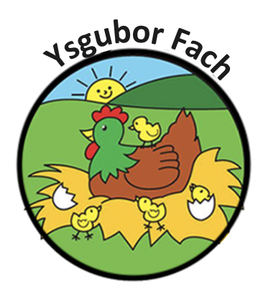

Health and Safety Policy
It is Ysgubor Fach policy to provide Children with a healthy, safe and stimulating Environment in which to work and play. If good health habits are developed early in life they are to be continued throughout life.
Procedures
Safety precautions: The main entrance to the building is always open, while the secondary door is always closed and has a security buzzer system in place, that ring’s directly into the toddler room and you can be seen via camera and microphone through a tablet. Fire drills are carried out once a month. These will be recorded, and fire equipment checked and service frequently. All staff have trained in an event of an emergency and they hold a paediatric first aid certificate. There is a cosh file in the office. All staff must wear disposable gloves and aprons as necessary part of our policy when changing a child. Emergency contacts telephones numbers, addresses, medical history and list of known allergies are kept in the office in the child file.
All outdoor areas will be checked and cleaned before the children use them.
Parents must inform the nursery who will be collecting their child on the day, if anybody different (please refer to our Collection policy for more information).
Indoor: The activities on offer will meet the needs of the group, providing the children with challenge and opportunity for success. The rooms will be bright and cheerful and equipment will be accessible for the children. Dressing up clothes, blankets and aprons will be washed regularly. Children will be encouraged to respect their environmental they will help to tidy away at the end of a session.
Kitchen
The kitchen area and work surfaces will always be kept clean. The work tops will be wiped and disinfected after each use. The fridge will be kept at the right temperature. Staff must use good frequent hand washing and the children are encouraged to wash their own hands, especially after using the toilets, handling the animals or before eating. Disposable towels and hand sanitiser is provided.
Our Policies and Procedures are reviewed yearly.
Many Thanks,
Eleri Thomas

