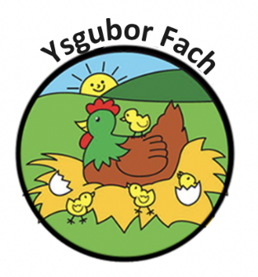

Notice of Removal Policy
Your child’s place may be withdrawn if you do not pay his/her fees.
Upon receiving your invoice at the end of the month, payment is due to be paid before the 6th of the following month, if payment is not made by the 10th of the following month the child’s place will be suspended until payment is made in full. If the invoice if not been paid by the end of the following month a notice of termination will be sent to the parents which means their contract has been terminated with Ysgubor Fach. This termination email/letter will also include an updated invoice with the 4 weeks’ notice payment added, along with any late fees.
Parent’s who still send their children in, upon the suspension or termination letters, will be unfortunately turned away at the door until the payment matter is resolved.
Ysgubor Fach requires four weeks’ notice in writing if you wish to withdraw from this contract.
You are liable, for all fees during the period of notice.
If your child’s presence at the nursery is harmful to their own or another child’s well, being we reserve the right to withdraw your child’s place. In these circumstances, we will waver the period of notice.
We will also reserve the right to withdraw your child’s place, and again under these circumstances, we will waver the period of notice. If a parent poses difficult to work with, staff have the right to voice if they are unhappy to work with a parent due to their communication and behaviour. If this is the case, we will be informing parents that their child’s place has been withdrawn from the nursery.
Ysgubor Fach must be contacted if your child is to be absent, if not, we may contact you ourselves.

Our Policies and Procedures are reviewed yearly.
Many Thanks,
Eleri Thomas

