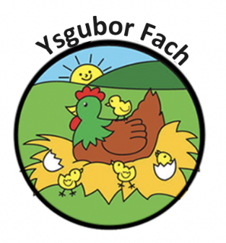

Hygiene in the kitchen
Before the adults prepare or handle food, they must wash their hands thoroughly and protective clothing must be worn i.e., apron and hair net.
All food should be piping hot and above 75 degrees Celsius
Staff must use the appropriate chopping boards when handling meat, fish, fruit and vegetables. All food should be covered and refrigerated where appropriate.
All waste food should be disposed of in the appropriate bins and hands washed after use.
DISHCLOTHS AND TEA TOWELS TO BE WASHED DAILY

Our Policies and Procedures are reviewed yearly.
Many Thanks,
Eleri Thomas

