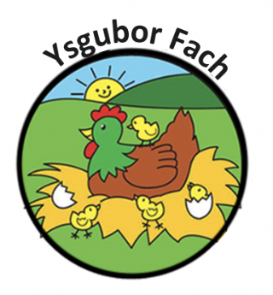

School Pick up Policy and Procedure

Ysgubor Fach offers a pick-up service for children who attend local primary schools in walking distance . This service applies for morning drop-offs, lunchtime for nursery class children and at the end of the day for our After School Club. The children will be collected by a qualified member of the Ysgubor Fach team and will be walked to their drop off point. The children will be accompanied by a member of staff at all times.

The following procedures are to be followed at all times:
- All members of staff taking children to school will have a current and clear DBS check.
- Each child will always be held by the hand by the staff member whilst being escorted to and from school.
- The member of staff will carry a mobile phone with them whenever they are on school run-in case there is an emergency, this is the only time staff are permitted to carry their personal mobiles with them during working hours.
- Staff to child ratio’s will always be maintained at the correct levels within the nursery whilst other members of staff are out on school runs.
- The children’s diary will be done a month in advance and will need to book their children in for pickup a month in advance to ensure clarity of school drop off’s and pickups.
- If for any reason a child is not picked up by the nursery and it is the fault of the nursery, the nursery manager will follow up with an investigation and produce a report as to why this has happened.
All policies and procedures are reviewed yearly by the management team.
E Thomas

