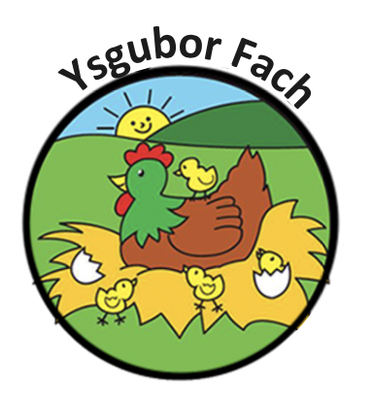

Child Ratio Policy

Ysgubor Fach will operate using the following ratios:
Children aged 6 weeks to 2 years : 1 Adult 3 Children
Children aged 2 years to 3 years : 1 Adult 4 Children
Children aged 3 years to 5 years : 1 Adult 8 Children

The staff: Child ratio will be maintained at all times when on the nursery premises.

Our Policies and Procedures are reviewed yearly.
Many Thanks,
Eleri Thomas

