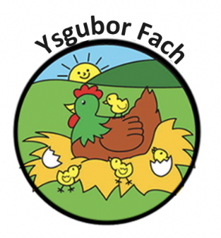

Children’s Participation Policy
At Ysgubor Fach we recognise that involving children in decisions about their care increases their self esteem and it is our policy to include the voice of the children in our care in all aspects of our work.
Ysgubor Fach aims to develop children’s participation by:
- Ensuring staff employment positive attitudes about children’s participation in their work.

- Provide staff training as appropriate

- Engaging with the children in our care in ways that are appropriate to their age and stage of development to enable their involvement in review and feedback activities.

- Respecting children’s decisions to not engage in review and feedback activities.

- Listening to what children say to us and taking action when required

- Feeding back to children who have contributed and informing them of any actions that have taken place as a result.

Our Policies and Procedures are reviewed yearly.
Many Thanks,
Eleri Thomas

