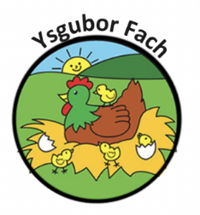

Procedures to follow if a child is unwell
- Always report any signs of illness in a child to your supervisor on duty.
- Check the child’s temperature, if it is over 39 degrees contact parents immediately
- If a child has more than three dirty nappies in three hours or less, contact parents immediately
- If any unidentified rashes or sports appear on a child, contact parents immediately
- If any condition is suspected to be infections, separate the child from the other children until the parents arrive. This must be done without making the child feel different.
- Do not give any medication even Calpol without the parents’ permission
- If parents can not be contacted and the condition appears to be serious, collect their emergency medical consent form and seek medical advice, the supervisor on duty should be the person to do this.
- Any action taken must be recorded in the incident book, the incident book must then be signed by the supervisor on duty and by the parents.
A child will not be accepted into nursery if:
- They have any unidentified spots or rashes
- If they have a high temperature
- If they have been experiencing loose stools
- If they have anything contagious, a doctor has not cleared them to return
- If they seem to be generally unwell (within reason)
The nursery will send for a parent/carer during a session, if a child develops any of the following;
- Spots/rashes
- A high temperature
- Anything which may appear to be contagious
- Diarrhoea
AFTER YOUR CHILD HAS HAD ANY SICKNESS OR DIARRHOEA RE-ENTRY TO THE NURSERY WILL NOT BE ALLOWED FOR 48 HOURS AFTER THE LAST EPISODE. WE ARE VERY STRICT ON THIS
Our Policies and Procedures are reviewed yearly.
Many Thanks,
Eleri Thomas

