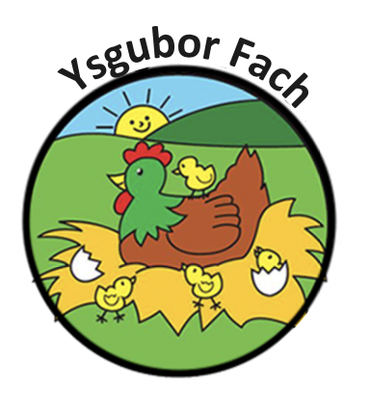

Food Hygiene Policy
Before preparing or servicing food for the children, the staff will ensure that:
- They are wearing an apron or tabard over their own clothes
- They have removed all items of jewellery
- All nail varnish has been removed
- All hair tied back
- They have washed their hands in the sink allocated in the kitchen
- All surfaces that food is likely to come into contact with, will be thoroughly cleaned and disinfected.

Our Policies and Procedures are reviewed yearly.
Many Thanks,
Eleri Thomas

