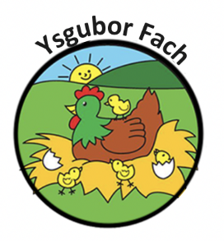

SNOW AND ADVERSE WEATHER POLICY
The safety of our children, staff and the families who use our nursery is of the utmost importance to us. We will therefore endeavour to remain open where possible during bad weather conditions, but this will heavily depend upon a number of circumstances.
1) If we are predicted bad weather/ snow we MAY make the decision to close the nursery the following day. In this situation, If the nursery remains open during bad weather conditions, we will aim to operate as normal for as long as possible. This will however depend upon; how many staff members are able to safely travel to work, the nursery building inside and outside is accessible and safe, and the temperature is suitable for the children when inside. We cannot and will not remain open unless the minimum correct adult: child ratio can be met. Therefore, if the nursery opens and only a certain number of staff members can work on this day, unfortunately the children that we are able to accept on that day will be based on a first come first serve basis. We will aim to contact other staff members from our wider team and our Bank Staff members, but we are not able to go over the required ratio number. If this situation happens, we will call families who are due in this day and explain the situation.
2) If the nursery is open as normal and we have bad weather during the day, the Nursery Owner (Eleri Thomas) will have the final judgement on whether the nursery remains open for the day and for how long this might be. In their absence, the Nursery Manager (Gwawr Lewis) will have the final judgement. We will seek advice and follow in due course with the Local Schools and closures in the area. The safety of everyone accessing the nursery is the most important thing, and if we feel parents need to start collecting their children to get home safely, phone calls will be made to all parents to inform them of our decision.
3) Staff members will be sent home in order of distance or personal circumstances, but only as and when ratios are correct within the nursery.
Due to the weather being out of the nursery’s control we are under no obligation to refund any payments made for days where closure is out of our control.
Snow can be very exciting for the children, and we like to be able to make these times fun for the children and incorporate learning opportunities. Most of the time travel and the operation of the nursery can remain normal, but we ask that all parents understand the need for safety when faced with bad weather.

Our Policies and Procedures are reviewed yearly.
Many Thanks,
Eleri Thomas

