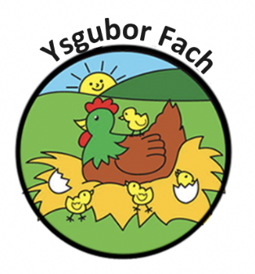

Employment Policy
Equal opportunities are vital amongst the staff. All efforts will be made to ensure that the premises are accessible to those with disabilities. Equal opportunities will be considered in all aspects of the staff terms and conditions and will be reviewed regularly. The nursery aims to ensure that no staff suffers offensive language in their workplace from other members of staff, parents or children.

Staff training needs in issues of equal opportunities will be reviewed regularly and arranged as appropriate.
Monitoring, review and responsibility

Equal opportunities strategies will be regularly reviewed and monitored. They will all be done as an on-going practise. An annual major review will take place.

Our Policies and Procedures are reviewed yearly.
Many Thanks,
Eleri Thomas

