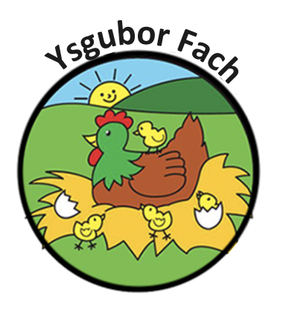

Early Years Log (EyLog) Policy
EyLog is early years Log, an EYFS compliant and secure online learning journey. It is an integrated web and tablet based secure application for nurseries and childcare providers to easily capture observations and manage the learning and development journey of a child in an electronic format. EyLog is an application that runs on a tablet PC (or simply 'tablets') and on the web. Nursery staff can use the EyLog practitioner app on tablets to capture photos/videos/audio clips, complete an observation of a child and link the observation to EYFS. These observations taken on the tablets are saved to EyLog’s central servers and become an integral part of the child’s learning journey which can be accessed from anywhere. EyLog also provides a 'web application' i.e., an application accessible through your web browser (such as Internet Explorer or Google Chrome). Nursery staff can view the observations saved from the tablets here, update and/or complete them at a later point in time as required. Room leaders and managers can also login via the web application to update and review these observations. EyLog also provides a one-stop view of all the observations recorded and extensive reports to the nursery owner and administrators for all the settings within a nursery chain.
EY Log allows staff to capture a photo, video clip or voice recording as well as written notes using a tablet computer. It also enables staff to make observations about childrens development. Staff and parents are able to communicate via this app.
Parents will be given a secure log in and password, which will only be accessed by themselves. All information is kept between the nursery and the individual parents. Any pictures taken or any information recorded will be done via the Ysgubor Fach Ipads only.
All parents will be given information on the new EY Log system and will be asked to provide a consent form in order for us to record information. Consent forms can be found in the child’s folder. Email addresses or any child information on this form will only be used for the purpose of EYlog activity.
Any EYFS Framework will be recorded and only accessible to staff, unless Management chose to share information with parents. Parents have the right to access any information held regarding their child at any time under GDPR legislation.
The ipads will be used for the purpose of the Ey Log system and to take pictures of any children.
Only staff, with access to an individual pin code, will be able to access onto the EY Log system. Observations and recordings will be made under each staff’s individual name.
Any misuse of children’s information will result in immediate removal of staff from the EY Log system and disciplinary action will be taken.
All child information is secured securely on all deviced, under GDPR legislation.
All data is stored on secure cloud-based servers which are hosted in a UK data centre. Eylog use Rackspace which is the UK’s leading cloud provider, please refer to Rackspace’s Security and Compliance policies for further details. Only the core eyLog team have access to the individual production cloud instances. The names of children/practitioners, etc., are all stored in secure databases which are not accessible to any search engine. All access to nursery data is protected by user-IDs and passwords preventing any search engine from crawling them. When a child leaves their childcare setting, the nursery has the option to make a child inactive or remove the child from the system. Whilst a child is inactive, the nursery or the parents (depending on the nursery’s policy) can download the entire learning journey including photos/videos/etc., as an e-Book. Inactive children's data will be stored for 12 months before being automatically deleted. Once the child is removed from the system either by the nursery or automatically, their data is permanently deleted and the nursery/parent will lose all access to it.

Our Policies and Procedures are reviewed yearly.
Many Thanks,
Eleri Thomas

