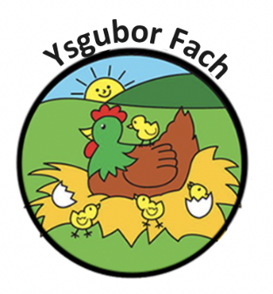

Use of Social Networking Sites
All parents and staff must follow restrictions when using social networking sites:
- Must NOT mention the nursery, staff, parents, or children during discussion on any social networking sites, sharing posts from the official Facebook or Instagram page is allowed.
- Staff must NOT use social networking sites during working hours.
- If any staff members have parents as friends, then there should be NO discussion of the nursery, staff, or their child/children. If parents have any queries/concerns regarding their child, nursery or staff this should be discussed in a professional manner with management at the nursery
- If a parent or staff posts about the nursery running or the staff, regardless of names and business name being used, as you may share our posts previously, this would be classed as defamation of the business.
- Staff must NOT mention their place of work on their personal profile page but can share content from the nursery Facebook and Instagram page, as all content has approval from parents.
- There MUST not be any pictures of the nursery, children, or staff unless it’s shared (with the permission of parents and staff) from the official nursery Facebook or Instagram.
- If/When your employment in Ysgubor Fach commences, then you must continue to follow restrictions such as: discussing the nursery, staff, parents, or children on any social networking sites
If any staff members do not adhere to this policy, then disciplinary action will be taken. This could lead to instant dismissal depending on the restrictions you have breached, otherwise it will be as details in the disciplinary policy.
If any Parents do not adhere to this policy, then you will be in breach of contract, which falls under the misconduct of the nursery and may result in your child’s place being suspended or expelled upon further investigation.
Our Policies and Procedures are reviewed yearly.
Many Thanks,
Eleri Thomas

