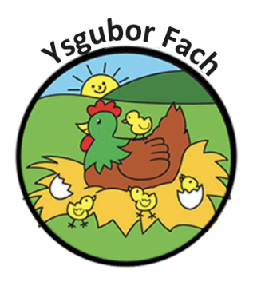

Confidentiality Policy
At Ysgubor Fach we work very closely with children and their families on a day-to-day basis. It is a legal requirement for the nursery to hold relevant information for each child and their families, which remains confidential at all times. This information is used for registers, invoices and emergency contacts. All records will be stored in a locked cabinet in line with the General Data Protection Regulation (GDPR).
CONFIDENTIAL ISSUES MAY INCLUDE:
• Child details - Including developmental needs and behaviour.
• Parent details - Including their domestic circumstances.
• Nursery working practices and policies.
• Nursery financial dealings.
• Staff details

PROCEDURE
It is our intention at the nursery to respect the privacy of children and their families which is achieved and maintained by following and keeping up to date with the current General Data Protection and Regulation (GDPR)
• Storing confidential records in a locked filing cabinet.
• Ensuring that all staff, volunteers and students are aware that this information is confidential and only for use within the nursery.
• Ensuring that parents have access to files and records of their own children, but not to those of any other child.
• Gaining parental permission for any photographs of the children to be used within the nursery.
• Ensuring that staff have a professional relationship with all parents and don’t become too familiar with particular families within the nursery.
• Ensuring that staff are aware that information held for each child is confidential, and only to be used within the nursery setting. If any of this information is requested for whatever reason, the parent’s permission must always be sought.
• Ensuring that staff do not discuss personal information given by parents with other members of staff, except where it affects planning for the child’s needs.
• Ensuring that staff, student and volunteer inductions include an awareness of the importance of confidentiality.
• Ensuring that staff, students and volunteers are aware of, and follow, the nursery’s social networking policy in relation to confidentiality.
• Ensuring that any concerns/evidence relating to a child’s personal safety are kept in a secure, confidential file. This information must be shared with as few people as possible on a need-to-know basis. If however, a child is considered at risk, the nursery’s safeguarding children policy will override confidentiality.

STAFF AGREEMENT
• All areas of confidentiality must be adhered to at all times. At no time whilst in employment and after termination of employment with Ysgubor Fach are you to divulge any of our clients’ details, working practices, policies or financial dealings to any other party.
• When taking on any private baby-sitting arrangements you must remain professional and ensure that confidentiality of the nursery is considered at all times.
• No information regarding other children or problems within the organisation is to be discussed with parents when baby-sitting is privately arranged. You must never become too familiar with parents and must ensure that this agreement is adhered to.
• When feedback is given at the end of each child’s session you must ensure that it is done in a professional way, giving the parent all the information that they need to know about their child’s day. If you have had a particularly bad day or a particular issue had arisen within the nursery, at no time must you express your opinion to, or in the presence of parents as they drop off or collect their child.
• You must ensure you are aware of and follow our social networking policy in relation to confidentiality. If staff, students or volunteers in the nursery are to breach any of the confidentiality provisions, including the above agreement, it is considered gross misconduct. Any staff found to have committed gross misconduct will result in a disciplinary action, and in serious cases, immediate dismissal without notice.

I hereby understand and will adhere to the above confidentiality policy and staff agreement.

Our Policies and Procedures are reviewed yearly.
Many Thanks,
Eleri Thomas

