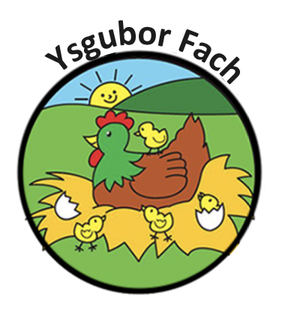

HEAD LICE POLICY
In response to a ‘Attitudes to Head Lice Questionnaire’ which was carried out, the majority opinion is that something needs to be done to combat the head lice problem.
94% of parents agreed that if parents fail to clear their child’s hair of head lice, they should be asked not to bring their child to the nursery until their head lice has been cleared.
We have therefore devised the following for the Nursery users:
- If live head lice are seen on a child’s hair, the parent will be informed immediately
- The parent will be asked to make sure that the head lice are removed
- If the head lice are not removed from the child’s hair then the parent could be asked not to bring the child to the Nursery until the hair has been cleared of head lice.

Our Policies and Procedures are reviewed yearly.
Many Thanks,
Eleri Thomas

