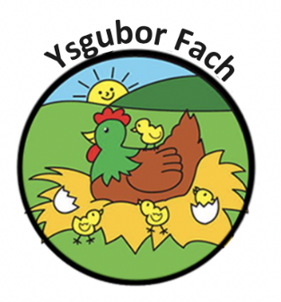

Animal Policy
Children learn about the natural environment, its animals and other living creatures, as part of the Early Years Foundation Stage curriculum. This may include contact with animals, or other living creatures, either in the setting or during outings/visits. We aim to ensure that this is in accordance with sensible hygiene and safety controls.

Procedures
Animals in the setting as pets
- We take account of the views of parents and children when selecting an animal or creature to keep as a pet in the setting.
- We carry out a risk assessment with a knowledgeable person accounting for any hygiene, allergies or safety risks posed by the animal or creature.
- We provide suitable housing for the animal or creature and ensure it is cleaned out regularly and kept safely.
- We ensure the correct food is offer at the right times.
- Children are taught correct handling and care of the animal or creature and are always supervised.
- Children wash their hands after handling the animal or creature and do not have contact with animal soil or soiled bedding.
- Staffs wear disposable gloves when cleaning housing or handling soiled bedding.
- If animals or creatures are brought in by visitors or other parents they are the responsibility of the owner.
- The owner carries out a risk assessment, detailing how the animal or creature is to be handled and how any safety or hygiene issues will be addressed.

Our Policies and Procedures are reviewed yearly.
Many Thanks,
Eleri Thomas

