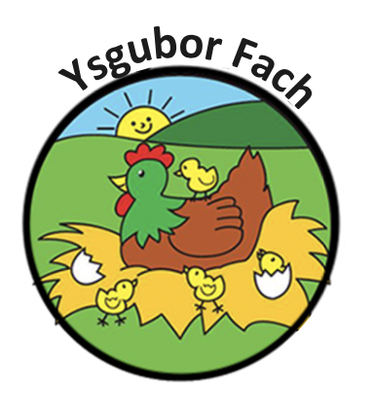

Abusive Parent Policy
At Ysgubor Fach we believe that we have a strong partnership with our parent/carer an open-door policy to discuss any matters arising. In the unlikely event that a parent starts to act in an aggressive or abusive way at the nursery, our policy is to:
- Direct the parent away to a private place away from the unfolding situation
- Act in a calm and professional way, ask the parent to calm down and make it clear that we do not tolerate aggressive or abusive language or behaviour
- Contact the police if the behaviour does not diffuse
- Once the parent calms down, the member of staff will then listen to their concerns and respond appropriately.
- Ensure that there is a second member of staff in attendance.
- An incident form will be completed detailing the time, reason and action taken.
- With incidents like this, staff may require support and reassurance following the experience.
- The nursery retains the right to stop an abusive parent on the premises and can be asked for another family member or carer to pick up their child.

Our Policies and Procedures are reviewed yearly.
Many Thanks,
Eleri Thomas

