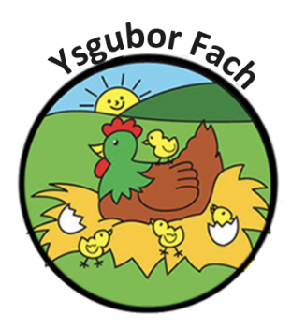

Sickness Policy
This policy has been devised to ensure that children who become unwell whilst at the
Nursery, are treated with sensitivity and respect. It is also to help us to protect other children
from illness and the spread of infection.
Ysgubor Fach is committed to ensuring the safety and well-being of the children in its care. To this end, Ysgubor Fach:
- Excludes any child with an infectious illness. The child will be excluded for the minimum period advised by the local authority.
- Advises parent/carers of these minimum periods and updates them as necessary, has procedures for contacting parent/carers or nominated persons and for caring for the sick child while awaiting collection.
- Has procedure for informing all parents/careers and staff of the presence of an infectious illness, with special regard for expectant mothers.
- Includes information about exclusion in parents’ induction material.
- Requires staff who are ill not to return to work in circumstances which could place children or staff at risk, and to keep their manager informed about the progress of their illness.
As a provider of day care, we realise that parents cannot afford to take time off work for every day cold or minor illnesses which their child contracts. However, to bring a child to Nursery when he/she is clearly suffering from an infectious disease is not fair to the other children, to their parents or to our staff. This is a difficult balance to strike and we will never please everyone; nurseries are criticised just as frequently for sending children home as they are failing to do so. Our staff are trained professionals, but they are not medically qualified and they have to exercised judgements in what they consider to be in the interests of all the children.
To help staff in exercising those judgements, we have a clearly stated exclusion policy, which follows guidance from the Health Protection Agency and which is made available to all parents on enrolment. The most frequent application of this policy is that children must not attend nursery for 48 hours after the last instance of sickness or diarrhoea. For more specific illnesses we follow the recommend exclusion guidelines, details of which are available on request.
In applying this policy, our staff is following strict instructions. Please do not put them in a difficult position, however inconvenient it may be.
Our Policies and Procedures are reviewed yearly.
Many Thanks,
Eleri Thomas

