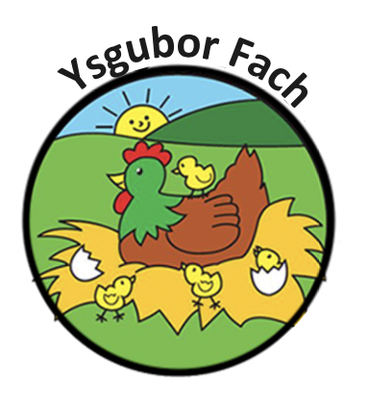

Acceptable Behaviour and Anti-bullying policy
Bullying in any form will not be tolerated at Ysgubor Fach.
This policy applies to adults as well as children.
We believe that everyone has the right to live and play, work and be in an environment where there is mutual respect and co-operation and that it is everyone’s responsibility to ensure that this happens.
Unacceptable behaviour can take many forms
- Name calling
- Being teased
- Being pushed or pulled
- Being hit
- Having your possessions taken or spoilt
- Having rumours spread about you
- Receiving nasty notes, text messages or e-mails
- Being ignored or left out
- Being forced to hand over money
- Receiving less favourable treatment
- Being attacked because of your religion, gender. Colour, sexual orientation, nationality or race
- Having unfair workloads or inappropriate expectations placed upon you.
If anyone suspects that a child or adult is being treated unfairly, they must report it immediately so that it can be dealt with appropriately.

Our Policies and Procedures are reviewed yearly.
Many Thanks,
Eleri Thomas

